FSC US Membership Overview and Application

The following information provides an overview of the FSC US membership program and includes the application form and next steps to becoming an FSC member. Membership is for all those who are seeking to support FSC and have a stronger voice in the governance of the FSC system. This application is intended for companies and organizations that are based in the United States. These members, if approved, will also be members of FSC International. If you are based in a country other than the United States, please contact membership@fsc.org for more information.

NOTE: If you are an FSC Certificate Holder you are not automatically an FSC member. If you are interested in becoming an FSC Certificate Holder, please visit the FSC Website at www.fsc.org.
TABLE OF CONTENTS | PAGE
Membership application checklist | 1
FSC mission and membership overview | 2
Reasons to become and FSC member | 3
Frequently asked questions about FSC membership | 3
FSC membership weighting of votes | 4
Description of the three membership chambers | 5
FSC US membership dues | 6
Current FSC members and how to become a member | 7
Application form for membership | 8

Application Checklist
Please review the following checklist and complete all applicable items. Send all of the following materials to FSC US at info@us.fsc.org for review and submittal to FSC Membership Committee. Membership fees due following approval of application.

Application Form – pages 8-10. Application must be filled out in its entirety.
Providing all publicly available supporting information:
Organizations only:
Organizational Statutes or Articles of Incorporation. For non-profit organizations, please include a copy of your 501(c)(3) letter of determination.
Any additional information to support your application, such as reports, history, newsletters, and brochures showing the aims of you or your organization.
The following is required if publicly available:
Financial information for determining membership level
List of Board of Directors and their affiliations
Annual Report
Individuals only:
Curriculum Vitae/ Resume
Policy for Association self-declaration form – page 11.
Letters of Support - Connect with two current FSC member to request two Letters of Support. Visit the FSC US website for a list of members. Contact FSC US if you need assistance in identifying current FSC members. See sample letter on page 12.
  - If the letter is from an organization, it MUST be signed by the Designated Representative, and if you are unsure who that is, please contact FSC US.

FSC Mission and Membership Overview

FSC Mission
The Forest Stewardship Council shall promote environmentally appropriate, socially beneficial, and economically viable management of the world’s forest.

What is FSC?

The Forest Stewardship Council (FSC) is an independent, member-led, non-profit organization that assures environmentally appropriate, socially beneficial and economically prosperous forest management through independent third-party certification and labeling of wood, paper and other forest products.

Based in Bonn, Germany, FSC was founded in 1993 in response to public concern about deforestation and demand for a credible wood-labeling system. FSC sets rigorous forest management and chain of custody standards, which are then used by third-party auditors to ensure that those standards are being met in the management of forests and the production of forest products. FSC’s on-product labeling allows businesses and consumers to choose products from well-managed forests—those that are managed to meet the social, economic and ecological needs of present and future generations.

FSC is also the only forest certification organization endorsed by such major environmental organizations as the World Wildlife Fund, National Wildlife Federation and Greenpeace.

FSC US is the national initiative of FSC and is headquartered in Minneapolis, Minnesota.

FSC Membership Overview
Like some mission-driven, non-profit organizations, FSC is membership-based. At FSC, we take it a step further and are membership-governed. FSC relies on the diversity of our members to give us voice, balance, and integrity.

FSC members are fundamental to the entire FSC enterprise and vision. Without a diverse and active membership representing social, environmental, and economic interests, FSC could not set the high yet realistic standards for forest management that have made FSC the world’s leading forest certification system.

It is important to note that if you are an FSC certificate holder this does not mean you are automatically an FSC member. The following information will provide you with all the materials you need to complete the membership application and make your voice heard.

FSC needs your participation as a member. The FSC system is built on the foundation of a strong, involved, and diverse, three-chamber membership base. With each new member, FSC becomes stronger and more grounded in true democracy. Please join in the mission today to protect the world’s forests for our children, grandchildren, and all future generations.

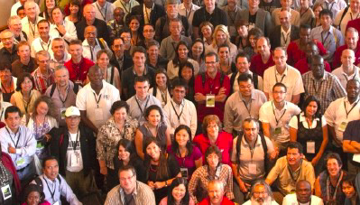
Reasons why YOU should become an FSC Member

- To show that you stand behind the mission and values of FSC as FSC demonstrates the breadth and commitment of its diverse membership.

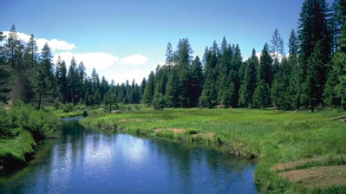
- To show that you, your organization, or business, supports responsible management of the world’s forest – supporting FSC contributes to your NGO’s mission or your company’s social and environmental commitments.

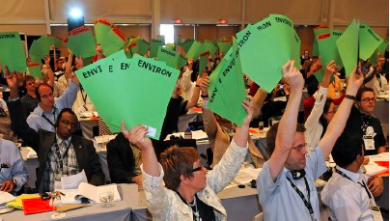
- To give you a voice in FSC governance and standards setting – as a member, you will vote on policy motions at FSC’s General Assembly, the main forum for FSC decision-making. You are also eligible to sit on FSC US and FSC International Board of Directors.

- To join a network of progressive peers who want to help encourage the responsible use of the world’s forest through the power of the marketplace.

Frequently Asked Questions about FSC and Membership

What is membership?

FSC is a membership association and is governed by its members.
Members represent their interests based on their professional activities, regardless of the type of membership (individual or organizational). The diversity of interests is reflected in the three-chamber structure that forms FSC membership: economic, environmental and social.

Members are divided into the following categories:

Type: Individual or Organizational
Chamber: Environmental, Social or Economic
Sub-chamber: North or South, based on whether you are legally registered in a high-income country (North) or non high-income country (South), according to the World Bank definition. The United States is in the Northern sub-chamber.

FSC members have the right to vote on policy motions and governance, including in the FSC International Board of Director elections. FSC members based in the U.S. may vote, as well as run as a candidate, in the FSC US Board of Director elections.

FSC members are encouraged to attend the FSC General Assembly, the triennial forum at which motions are presented and voted upon by members.

FSC members pay annual membership dues according to their type of membership.
Why is FSC membership structured to ensure chamber balance?

In order to balance the interests of different stakeholders, FSC is governed by three chambers that make decisions cooperatively. The three chambers represent environmental, economic and social interests. Each chamber in turn is divided into two sub-chambers, Global North and Global South, to guarantee equal weight of vote and influence among the various countries and economic powers represented. The votes of all individual members in each sub chamber represent only 10% of the total vote of the sub chamber, while the votes of all member organizations make up the other 90%.

Members based in the United States are in the Global North sub-chamber.

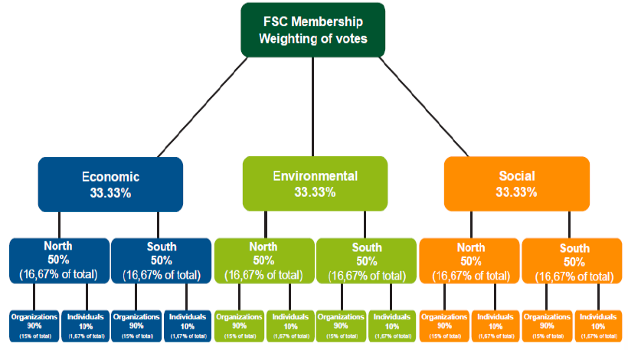

Who can become an FSC Member?

Individuals and organizations (businesses, non-profits, and government agencies) who support the idea of improved forest management around the world can become an FSC member. All members should demonstrate an active commitment to FSC and its Principles and Criteria.

Why should I become an FSC member?

FSC is a participatory association. The membership is the highest authority of FSC and the ultimate decision-maker. FSC relies on the diversity of our members to give us voice, balance and integrity. But not all FSC certificate holders and environmental and social stakeholders are members. Many simply do not realize that membership is an option – nor how important it is for FSC’s success.

FSC needs your participation as a member. With each new member, FSC becomes stronger and more grounded in true democracy. Please join us in our mission to see that more of the world’s forests are managed to FSC’s high environmental and social standards.

What are the three chambers of FSC?

To balance the interests of different stakeholders, FSC is governed by three chambers with equal vote and power to make decisions cooperatively. The three chambers represent environmental, economic and social interests. Each chamber is divided into sub-chamber north and south; the United States is in the “north” sub-chamber. This guarantees equal weight of vote and influence for the different interest groups as well as for different parts of the world and economic power.

Members of all FSC chambers demonstrate an interest in environmentally appropriate, socially beneficial and economically viable forest management, with demonstrated support of the FSC Principles and Criteria.

Individuals and research, academic, and technical institutions are eligible to become members. Members are fall into one of the three chambers based on the focus of their work.

Economic Chamber
The economic chamber is for those individuals and organizations that have a commercial interest in forest management and forest products. Such as manufacturers, forest managers, certification bodies, wholesalers, consumer associations, consulting companies, retailers, industry & trade associations (profit or nonprofit), and government agencies.

Environmental Chamber
The environmental chamber is for those individuals and organizations that have an active interest in the environmentally appropriate management of the world’s forests. Such as non-profits, non-governmental organizations, research, technical, and academic institutions.

Social Chamber
This chamber is for those individuals and organizations that have a commitment to promoting and encouraging the responsible management of the world’s forests because of the benefit for all people, workers, stakeholders, and indigenous populations. Such as non-profits, indigenous organizations, social movements, research, technical, academic institutions, non-governmental organizations, community organizations, and faith-based groups.

Who are the members of FSC?

The most up to date record of current members of FSC can be found at the following link.

All International FSC Members - http://chportal.fsc.org/PublicMemberSearch
FSC US Members - https://us.fsc.org/membership.184.htm

Will I receive regular information from FSC?
FSC maintains a special email and intranet to keep members updated on upcoming Accreditation Services International (ASI) audits, drafts of standards, newly accredited FSC working groups, Board of Director nominations and elections, and other information. Members also receive e-newsletters from FSC International Center and FSC US.

What does it cost to be Member?

The membership dues in the tables below apply to FSC members in the Northern sub-chamber, of which the United States is a part.

Applicants should not enclose membership dues payments with application. Once membership is approved by FSC International Center, new members will be billed by FSC US.

The fee structure for organizational members is based on either the number of employees the organization has or its turnover (revenues / expenses for non-profit organizations) depending on what is easier for you to measure.

FSC membership renews automatically at the beginning of each year, unless FSC is notified with a written cancellation of membership with at least a two-month notice. Pro-rated reimbursement for annual dues upon discontinuation of membership is not available.

Organizations:

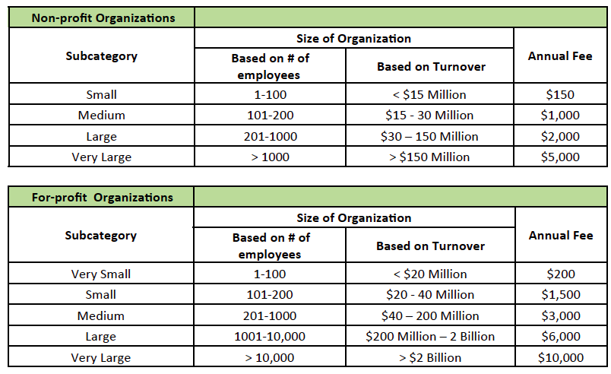

Individuals:

Who are the members of FSC?

The most up to date record of current members of FSC can be found at the following links.
- All International FSC Members – http://memberportal.fsc.org/
- FSC US Members - https://us.fsc.org/membership.184.htm and download PDF file

Will I receive regular information from FSC?

FSC keeps members updated on upcoming Accreditation Services International (ASI) audits, drafts of standards, newly accredited FSC working groups, Board of Director nominations and elections, and other information via email and member-only forums. Members also receive
e-newsletters from FSC International Center and FSC US.

How do I become a member?

Once you decide to take the next step towards becoming an FSC member, you will begin by looking over the checklist (page 1) and application materials (pages 8 to 12).

This includes:
- Filling out the application form (pages 8-10) and Policy for Association (page 11).
- Providing two letters of support from current FSC members (sample on page 12).
- Providing all publicly available supporting information (see checklist on page 1).
- Submitting the application and materials to FSC US at info@us.fsc.org.
- Waiting for review and approval by the FSC International Membership Committee.

NOTE: FSC US will invoice for membership dues upon approval of membership, so please do not send payment until notification of your application’s approval.

FSC US Membership Application Form

Application Type (Read more about weighting of votes on page 4):

Organizational application Individual application
Contact Information:

Name:
(If organizational applicant, name of Designated Representative)

Job Title:
(If organizational applicant, job title of Designated Representative)

Organization Name:

Street Address:

City: State: Zip Code:

Email: Phone:

Website:

Select Chamber that best reflects the work of you or your organization.

Economic Chamber
Environmental Chamber (only non-profit organizations and individuals)
Social Chamber (only non-profit organizations and individuals)
General Information: (Please do not exceed space provided.)

Brief explanation regarding your chamber designation:

Description of professional activities:

Description of applicant’s actions that support for FSC’s aims:
For Organizational applicants only:
(Note: Only legal entities can become organizational members of FSC.)

Are you a membership organization? Yes No

How many members do you have?

Size of Organization:

Non-Profit Organizations:

Small (1-100 employees or <$15 million turnover)
Medium (101-200 employees or $15-30 million turnover)
Large (201-1,000 employees or $30-150 million turnover)
Very Large (more than 1,000 employees or more than $150 million turnover)
For Profit Organizations:

Very small (1-100 employees or <$20 million turnover)
Small (101-200 employees or $20-40 million turnover)
Medium (201-1000 employees or $40-200 million turnover)
Large (1001-10,000 employees or $200 million - 2 billion turnover)
Very Large (more than 10,000 employees or more than $2 billion turnover)

We provide certification services (certification body, auditor): Yes No
We are an industry association: Yes No
We work for the government or are a
government-owned or -controlled body: Yes No

Organization Type:
a producer (forest management company, a plantations company)
a manufacturer (processor) a retailer a training organization
an investment company a wholesaler a development agency
a consulting firm a social NGO an environmental NGO
a consumer’s organization a trader / broker an indigenous organization
a research organization a union other ( )
an FSC certificate holder (code: )

Product Produced (if applicable):
garden furniture solid wood food
pulp and paper DIY forest management
printing / print material construction other ( )
education/ training non-timber forest products (NTFP)
Letters of Support – Attach letters from the following two FSC members. (Sample on page 13.):

1.

2.

I / we agree to allow FSC and FSC US to share my contact data with the following:
(Important: FSC will never sell member contact data to for-profit companies for purposes of solicitation. However, regardless of the selection below, all members’ contact data will be shared with FSC Secretariat; Regional Offices; National Offices; and Board members.)

Within FSC, with FSC Members and Networks Partners, and selected third parties such as researchers.
Only within FSC, as well as with FSC Members and Network Partners.
Our membership contact data may only be shared within FSC.
(Note: If you select this option, your contact data will not be shared with fellow FSC members upon request, including for purposes of intra-member communications in regards topics such as voting and member & chamber-related meetings.)

For all three chamber applicants:
Please provide your signature to indicate you agree and comply with the following statement:

I request membership in the Forest Stewardship Council (FSC A.C.). I hereby confirm that the information given in this application is correct, and that I / we support the aims and activities of the FSC, as well as its Principles and Criteria for forest stewardship. I attach all the documentation listed on the requirements checklist, including two letters of support and Policy for Association.

The signing individual /organization is associated with the FSC by being a member of FSC. Hereby the signing individual / organization explicitly states that he/she has read and understood the “Policy for the Association of Organizations and individuals with FSC,” to be submitted along with this application form.

I agree that my / our FSC membership will be made public. I am aware that FSC membership renews automatically at the beginning of each year, unless I sent to FSC a written cancellation of membership with 2 months’ notice.

Signature of Individual Applicant or Designated Representative

Printed Name Date

Please print the application, hand-sign, scan, and email a copy of the application as well as all items listed on the Application Checklist (on page 1) to info@us.fsc.org.

S e l f - D e c l a r a t i o n
regarding FSC-POL-01-004
(Policy for the Association of individual with FSC)

The signing individual is associated with the Forest Stewardship Council A.C., Oaxaca, Mexico, (hereinafter: FSC) by being either a member of or having a contractual relationship with FSC. Hereby the signing individual explicitly states that he/she has read and understood the “Policy for the Association of Organizations and individuals with FSC” as published under www.fsc.org. This policy stipulates FSC’s position with regards to unacceptable activities by organizations and individuals which already are or would like to be associated with FSC as well as the mechanism for disassociation.
In light of the above, the individual explicitly agrees currently and in the future, as long as the relationship with FSC exists, not to be directly or indirectly involved in the following unacceptable activities:
- Illegal logging or the trade in illegal wood or forest products;
- Violation of traditional and human rights in forestry operations;
- Destruction of high conservation values in forestry operations;
- Significant conversion of forests to plantations or non-forest use;
- Introduction of genetically modified organisms in forestry operations;
- Violation of any of the ILO Core Conventions as defined in the ILO Declaration on Fundamental Principles and Rights at Work.

City, Date

For the individual (Include the full printed name & authorized signature of the official Designated Representative for the Organization’s FSC Membership, or the Individual FSC Member)

Forest Stewardship Council A.C. · Calle Margarita Maza de Juárez 422 · Colonia Centro · Oaxaca CP 68000 · Mexico · T +52 951 502 6533 · F +52 951 502 6594 · fsc@fsc.org · www.fsc.org· FSC® F000100
Public Registry of Property and Commerce: Oaxaca · Mexico, Registration No. 38602

EXAMPLE LETTER OF SUPPORT

TO: Forest Stewardship Council
FROM: Member organization or individual
Name:
Address:
Phone:
Email:

On behalf of [Current Individual or Organizational Member Name], I am writing in support of the application by [Applicant Individual] to become a member of the Forest Stewardship Council (FSC). I know the work of [applicant name], and understand that they fully support the objectives and methods of FSC.

[Insert paragraph about why you feel they are a good fit for FSC membership]

I recommend the FSC-AC Board to approve the application.

Sincerely yours,

Signature of official Designated Representative for the Date
Organization’s FSC Membership, or Individual FSC Member

Print name of official Designated Representative for the
Organization’s FSC Membership, or Individual FSC Member

